NEWTON STEWART WALKING FESTIVAL 2023
PRIZE DRAW EVALUATION FORM

Tell us what you think! We would be very grateful if you would take a few moments to answer the following questions about your WalkFest experience this year. By completing the form (one only required per walker covering the whole week) you will be helping us improve WalkFest. You will also be eligible to enter our draw to win a £20 voucher to spend at Stewart R Cunningham Outdoor Centre. Please note that individual responses will be anonymised in any findings we publish or share with others.

Note: To tick one of the options, double click on it and select default value = “checked” (“not checked” is default)

Many thanks, WalkFest Committee www.walkfestnewtonstewart.com

- How did you first find out about WalkFest 2023?

Internet search WalkFest electronic newsletter VisitScotland Information centre/website

Other website link Word of mouth Facebook

D&G local magazine National magazine D&G local paper National newspaper

Radio / television Poster/banner Other (specify)

- How do you rate our website?

Excellent Very good Good Average Fair Poor Unacceptable

3. How do you rate our booking system (including paypal)?

Excellent Very good Good Average Fair Poor Unacceptable

- How do you rate our pre festival communications?

Excellent Very good Good Average Fair Poor Unacceptable

- How do you rate our registration arrangements?

Excellent Very good Good Average Fair Poor Unacceptable

- How do you rate our transport arrangements?

Excellent Very good Good Average Fair Poor Unacceptable

7. Which walk(s) did you do? Please name all walks and comment as you feel appropriate on the guides, the route and your general experience.

8. Which entertainment event(s) did you attend? Please list and comment as appropriate.

9. Have you attended Newton Stewart Walking Festival before?

Yes, once before Yes, more than once before No, this is my first time

10. Did you stay away from home during WalkFest?

I stayed at home with friends/relatives rented accommodation in own holiday home

11. If you stayed in rented accommodation – what type was it?

Hotel Guest House/B&B/Hostel Camping/Caravanning Self catering

12. How many nights did you stay in the Newton Stewart area as a result of attending Walkfest?

13. Please grade your overall experience of WalkFest.

Excellent Very good Good Average Fair Poor Unacceptable

14. What one thing you would like changed or added to make WalkFest better?

15. How would you grade WalkFest 2023 on value for money?

Excellent Very good Good Average Fair Poor Unacceptable

16. Your gender

Male Female

17. Your age

Under 24 years 24 to 55 years Over 55 years

18. To enter the prize draw please include your name and contact e-mail / phone number below:

Please leave completed forms in the box at the registration point or post back to:
Newton Stewart Walking Festival, c/o 9 St John Street, Creetown, Newton Stewart, DG8 7JA
or email to info@walkfestnewtonstewart.com
CLOSING DATE for entry into the prize draw is 31st May 2023



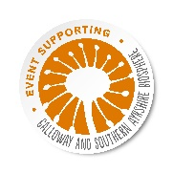


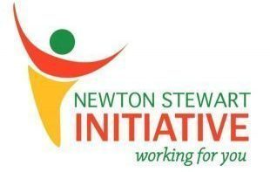
The Belted Galloway Visitor Centre

